How to Build the LEGO Crane
Eleven steps, from the baseplate upward
These steps are a reconstruction, not a record. They were worked out from a photograph of the finished bird, so the piece sizes are one plausible way to reach that shape rather than the exact pieces that were used. Substitute freely for whatever is in the bin — choosing the substitute is the design work, not a compromise.
Table 1. Every piece used, gathered by the part it builds.
Part | Color | Pieces
Baseplate | Green | 1 baseplate, 12 × 6
Legs | Black | 6 bricks, 1 × 1
Body | White | 1 plate 2 × 6; 1 brick 2 × 6; 1 brick 2 × 4;  1 brick 2 × 2; 2 slopes 2 × 1
Wings | Light Gray | 2 plates, 2 × 4
Neck | Light Gray | 5 bricks, 1 × 1
Head | Black | 2 bricks, 2 × 2
Eye | White | 1 round tile, 1 × 1
Beak | Red | 1 slope, 2 × 1
Crown | Yellow | 1 plate 2 × 2; 5 upright pieces

Step 1. Start with the baseplate
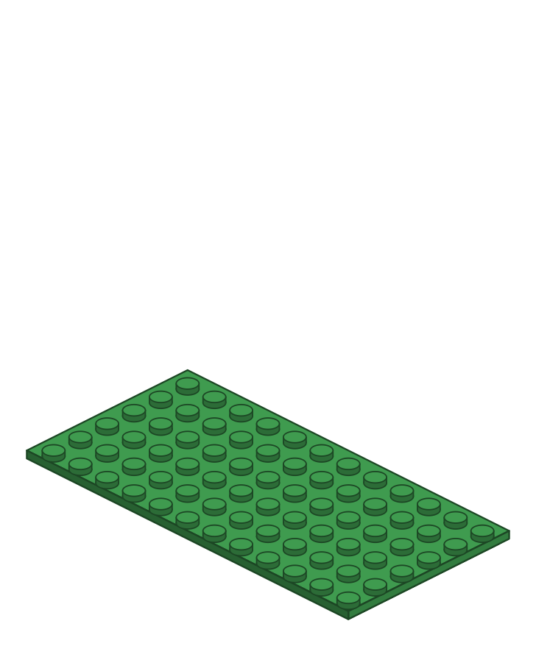
Everything stands on one green baseplate. Set it down with the long side facing you — the crane will face to the right.
Add these pieces: 1 green baseplate, 12 × 6
Step 2. Stand up the two legs
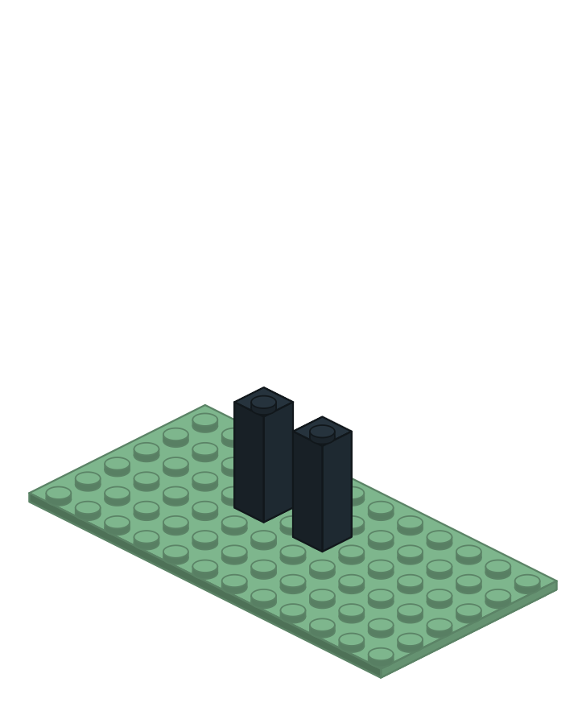
Stack three 1 × 1 bricks for each leg, two studs apart. Thin legs are the most fragile part of the whole bird — press every brick fully home.
Add these pieces: 6 black 1 × 1 bricks
Step 3. Bridge the legs with a plate
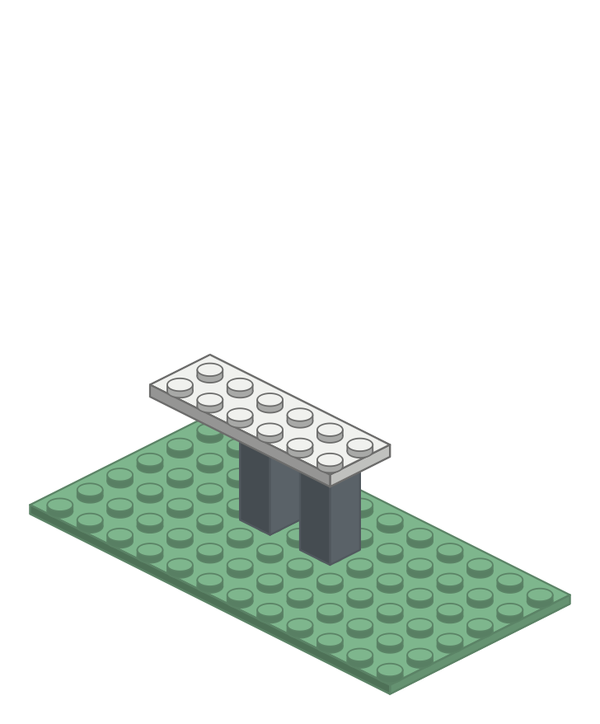
One long plate ties the legs together and becomes the underside of the body. This is the piece that stops the legs wobbling.
Add these pieces: 1 white 2 × 6 plate
Step 4. Build the body's first course
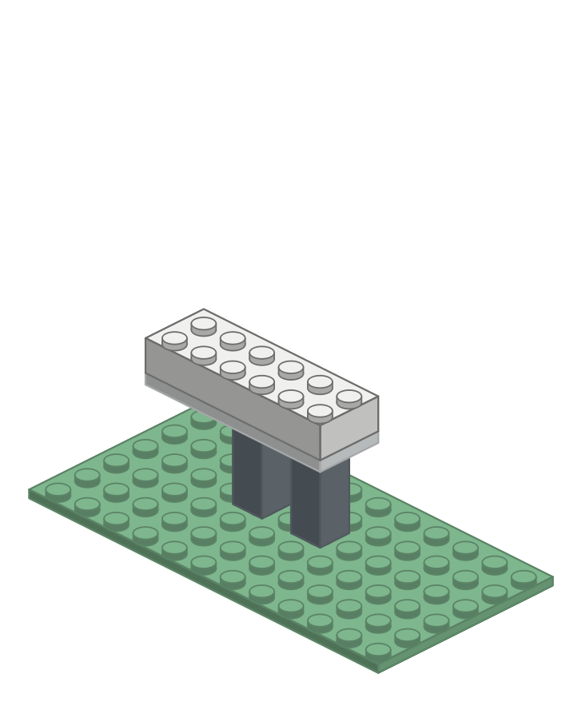
One long brick on top of the plate. The body needs real bulk — a bird built only of plates reads as a paper cutout standing on edge.
Add these pieces: 1 white 2 × 6 brick
Step 5. Slot the wings in at the sides
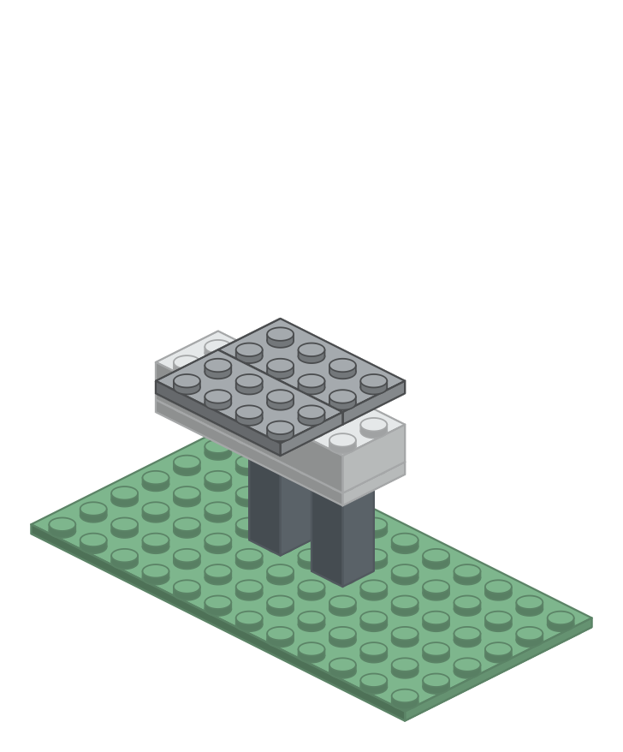
A plate each side, overlapping the body by one row of studs. They go on now, mid-body, so the next course pins them down — that is what makes them read as wings at the bird's flanks rather than a slab laid over its back.
Add these pieces: 2 light gray 2 × 4 plates
Step 6. Second course, and taper the tail
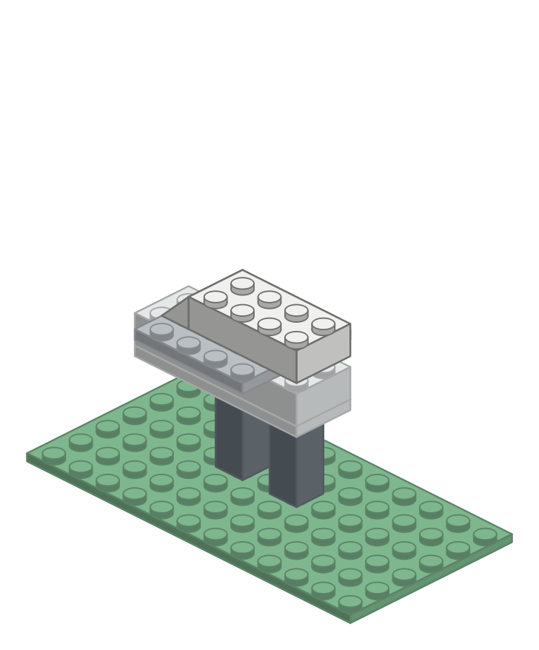
The next course pins the wings and steps in at the back, where a slope finishes the tail. This is where the block starts to read as a bird rather than a box.
Add these pieces: 1 white 2 × 4 brick; 1 white 2 × 1 slope
Step 7. Close the back and seat the neck
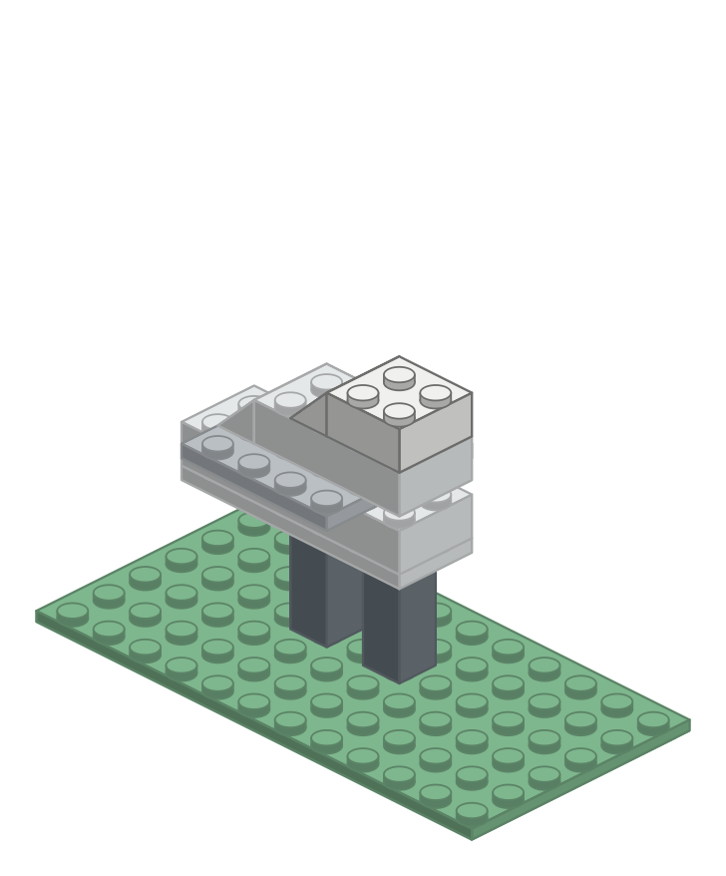
A 2 × 2 brick at the front gives the neck something solid to stand on; one more slope rounds off the back.
Add these pieces: 1 white 2 × 2 brick; 1 white 2 × 1 slope
Step 8. Raise the neck
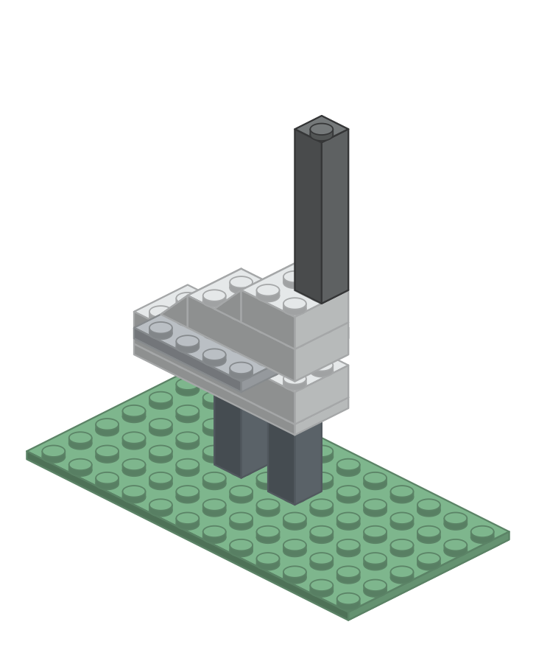
Five 1 × 1 bricks stacked straight up. The neck is the crane's signature — and at one brick wide it is also the piece most likely to snap. Pick the finished bird up by its baseplate, never by the neck.
Add these pieces: 5 light gray 1 × 1 bricks
Step 9. Set the head on top
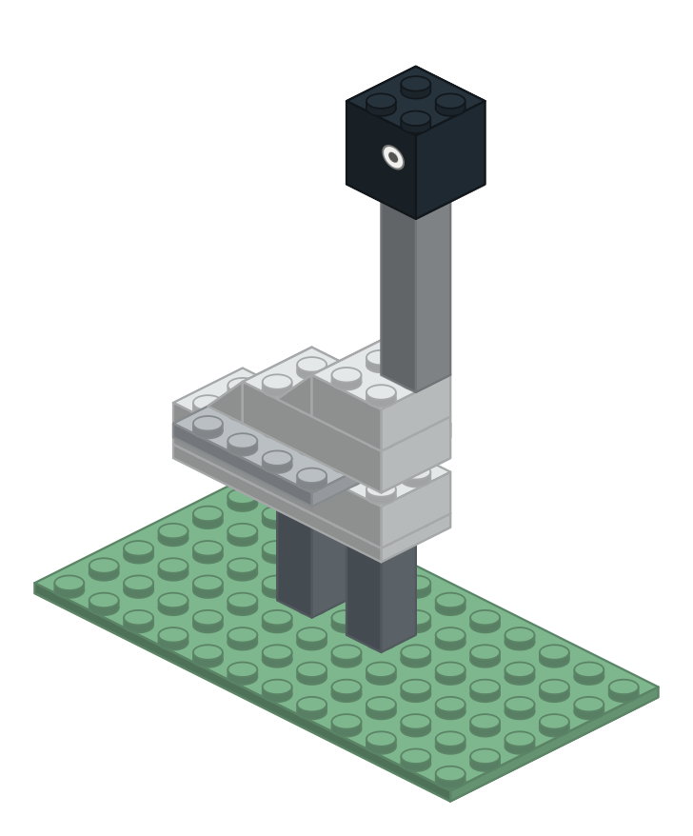
Two 2 × 2 bricks make the head, overhanging the neck toward the front. A white round tile on the side is the eye — one small piece that does more for the bird than any other.
Add these pieces: 2 black 2 × 2 bricks; 1 white 1 × 1 round tile
Step 10. Point the beak forward
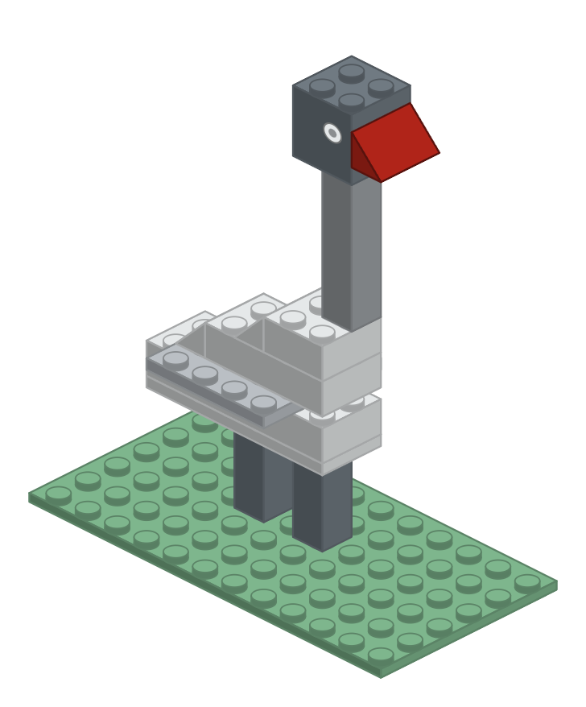
One red slope at the front of the head is the beak. The mosaic could only spell this out as a few red tiles; in brick it becomes a single wedge — a shape the 8 mm grid could never hold.
Add these pieces: 1 red 2 × 1 slope
Step 11. Finish with the golden crown
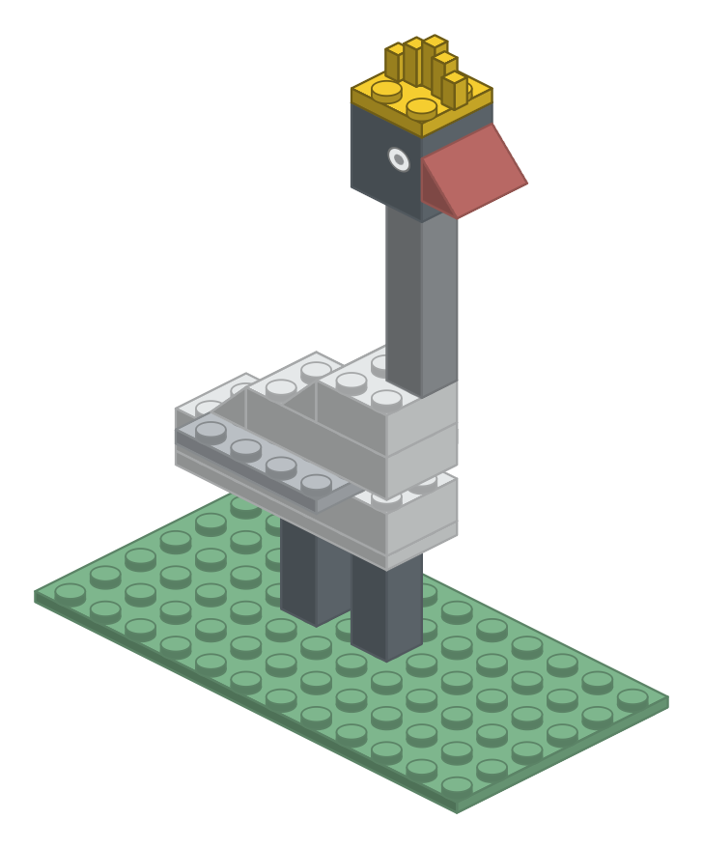
A yellow plate across the head carries the crown. Stand short pieces upright in a fan, tallest in the middle — this is the detail that names the bird, so spread them wide.
Add these pieces: 1 yellow 2 × 2 plate; 5 yellow upright pieces
When it is standing
Set the finished bird beside the mosaic it came from and compare them: the neck too short, the body too narrow, the crown too tight. Every difference you can name is the next revision. Because the bricks come apart as easily as they go together, changing your mind costs nothing — which is exactly what makes a prototype worth building.

